Project report

# Software Testing Project on Open Cart

An Ecommerce website

HARSHAVARDHAN REDDY PARPATKAM

2823441

CONTENTS

1. INTRODUCTION
2. ABOUT THE SOFTWARE
3. ENVIRONMENT SETUP AND DEPLOYEMNT
4. TEST DESIGN
5. TEST CASES
6. TEST RESULTS
7. CONCLUSION
8. DEFECT REPORTS

Introduction

This project is based on manual testing of a software named open cart, it is a Ecommerce shopping website where we can buy products online buy paying through different ways like credit ,debit and PayPal.

This project is divided into Four parts:

1. Test plan
2. Test cases
3. Test execution
4. Recording the results

Test plan was done before the project to maintain speed and reduce the work load

Preparation of test plan document to describe scope of the testing, it shows what features we need to test, when to test and who will test

Test plain contains a proper time line of the testing, what are the tools we need for testing, normally it takes a lot of time in order to complete a testing project, but having a proper test plan helps us to complete the project in a good time.

Things in Test plan:

Inclusion

Test strategy

Exclusion

Timeline

Test schedule

Tools

A test case is a sequence of procedures carried out to validate a certain feature or capability of your software program. A test case is a collection of test procedures, test results, preconditions, and postconditions created for a particular test scenario to validate any requirement. A testing engineer might use the test case's unique variables or conditions to compare expected and actual outcomes and assess if a software product is meeting the customer's need.

* Software to be tested

Name of the Software: Open Cart website

Website : https://github.com/opencart/opencart

Version: 4.0.1.1

Platform: Windows, macOS, Linux

Languages: php, java, css

Screenshots of the website

Home screen:

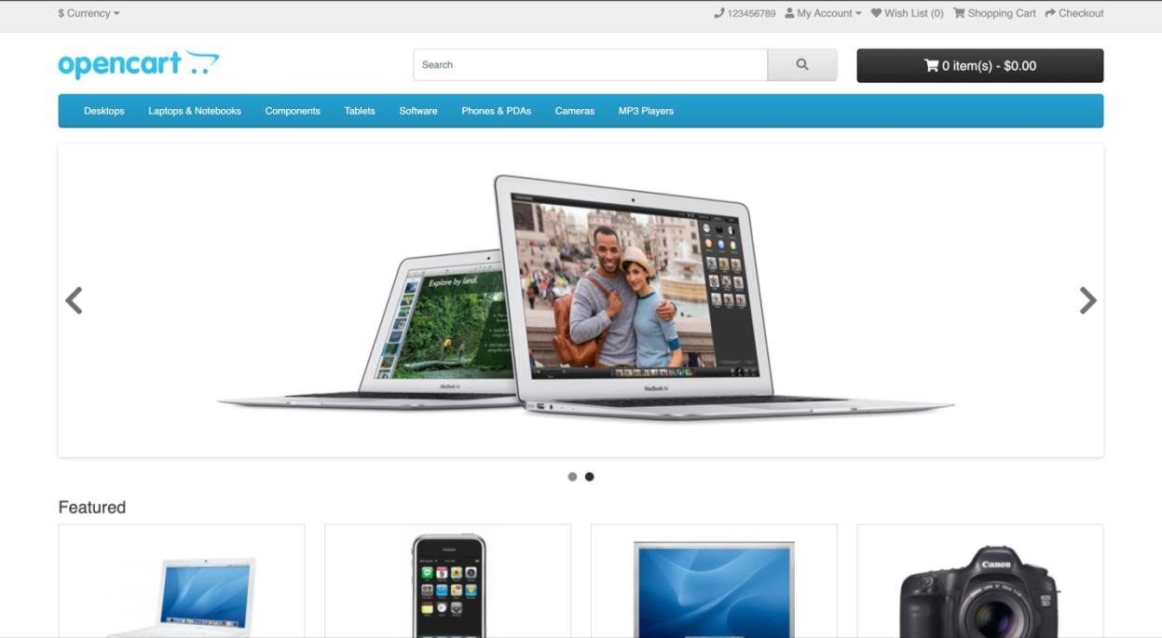

Creating an account:

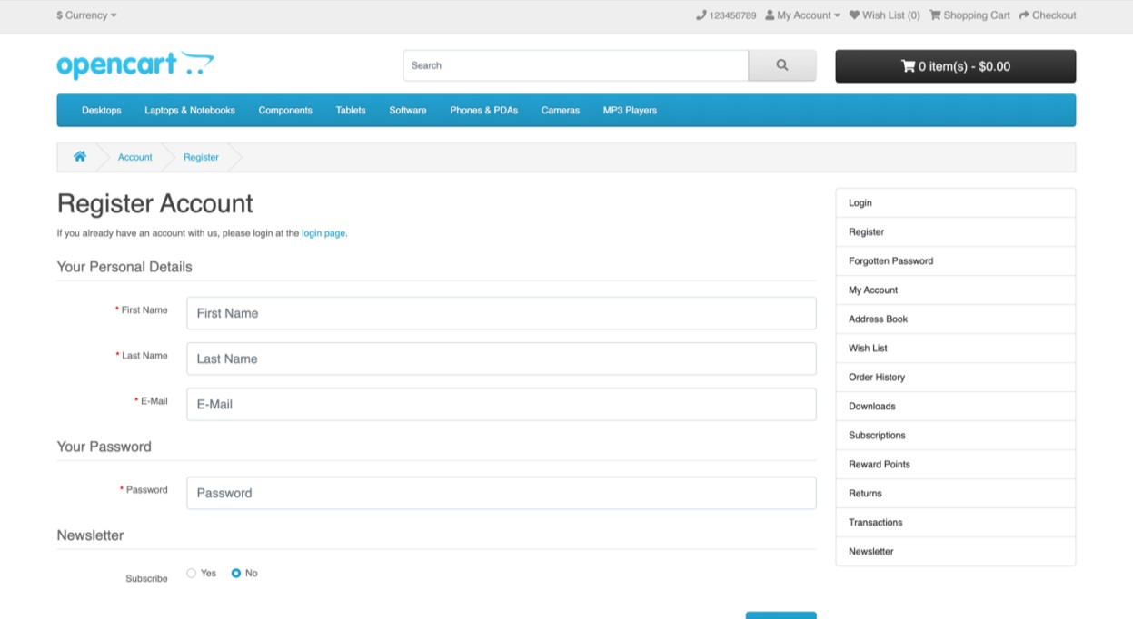

Login :

* Functions to be tested:
  + - * REGISTER
      * Login
      * Forgot Password
      * Search
      * Product Compare
      * Product Display
      * Page
      * Add to cart
      * Wishlist
      * Shopping Cart
      * Home Page
      * Checkout
      * My Account
      * Information
      * Change password
      * Address book
      * Order History
      * Product Returns
      * Payments
      * Contact Us
      * Options

* Testing strategy:

For the Functional Testing we will follow the below process or approach

* + - Creation of different types of Test scenarios and Test Cases for different types of features of this website
    - Usability testing by Use case testing
    - Error guessing
    - Exploratory Testing

The testing will be performed in multiple phases, including unit testing, system testing, and acceptance testing. The purpose is to identify defects, validate functional requirements, and ensure the software meets end-user needs.

System testing

* + - * System testing will verify that the application functions as a cohesive system, with all components integrated and interacting as intended. The testing will include functional, performance, security, and usability tests. Test cases will be designed based on use cases, user stories, and other requirements documentation.
      * Here for this Software the System testing is done in following steps
      * Test environment setup
      * Setting Test cases
      * Test Data
      * Executing Test Cases
      * Reports
* Test work products:

* + - Test plan document
    - Test cases
    - Test scripts
    - Test data and input files
    - Test drivers and stubs
    - Test reports and logs
* Test record keeping :

Test results and logs will be stored in a centralized test management system, allowing for easy access, tracking, and analysis of test outcomes.

The system will allow for real-time collaboration among team members, enabling quick identification and resolution of issues. Metrics such as test coverage, defect density, and defect resolution time will be monitored to assess the overall effectiveness of the testing process.

Here for this software we keep records and record in Microsoft word and excel

* Testing tools and environment

* + - Test Environment: Dedicated test servers and virtual machines for various platforms (Windows, macOS, Linux)
    - Test Management Tool: Apache netbeans, mysql, xampp
    - Version Control System: Git
    - Deployed using xampp and tested in google chrome

# Test cases and results

|  |
| --- |
| Register  Login  Logout  Forgot Password  Search  Add to cart  Wishlist  Shopping Cart  Home Page  My account  Change Password  Order History  Order Information  Product returns  Header menu footer options  Special offers  Gift Certificate  currencies |

|  |  |
| --- | --- |
| Test Case Title | Validate Registering an Account by providing only the Mandatory fields |
| Test Case Identifier | TC_R_001 |
| Test Items/feature | REGISTER FUNCTIONALITY |
| Preconditions | Open the application in any browser |
| Test Steps | 1. Click on 'My Account' Drop menu 2. Click on 'Register' option 3. Enter new Account Details into the Mandatory Fields (First Name, Last Name, E-Mail, Telephone, Password, Password Confirm and Privacy Policy Fields) 4. Click on 'Continue' button 5. Click on 'Continue' button that is displayed in the 'Account Success' |
| Output Specifications | 1. User should be logged in, taken to 'Account Success’ page and proper details should be displayed on the page  2. User should be taken to 'Account' page and a confirm email should be sent to the registered email address |
| Inter-case Dependencies | NA |
| **Test Result** | **Passed** |

|  |  |
| --- | --- |
| Test Case Title | Validate 'Thank you for registering' email is sent to the registered email address as a confirmation for registering the account |
| Test Case Identifier | TC_R_002 |
| Test Items/feature | REGISTER FUNCTIONALITY |
| Preconditions | Open the application in any browser |
| Test Steps | 1. Click on 'My Account' Drop menu 2. Click on 'Register' option 3. Enter new Account Details into the Mandatory Fields (First Name, Last Name, E-Mail, Telephone, Password, Password Confirm and Privacy Policy Fields) 4. Click on 'Continue' button 5. Check the email address used for registering the account 6. Click on the Login page link from the Email body. |
| Output Specifications | 1. Validate a confirmation email for registering the account is sent to the registered email address.  2. Validate the Email subject, body and from address of the received email. 3. Validate there is a link to the login page provided in the Email body 4. User should be taken to the Login page |
| Inter-case Dependencies | NA |
| **Test Result** | **passed** |

|  |  |
| --- | --- |
| Test Case Title | Validate Registering an Account by providing all the fields |
| Test Case Identifier | TC_R_003 |
| Test Items/feature | REGISTER FUNCTIONALITY |
| Preconditions | Open the application in any browser |
| Test Steps | 1. Click on 'My Account' Drop menu 2. Click on 'Register' option 3. Enter new Account Details into all the Fields (First Name, Last Name, E-Mail,Telephone, Password, Password Confirm, Newsletter and Privacy Policy Fields) 4. Click on 'Continue' button (ER-1) 5. Click on 'Continue' button that is displayed in the 'Account Success' page (ER-2). |
| Output Specifications | 1. User should be logged in, taken to 'Account Succcess' page and proper details should be displayed on the page 2. User should be taken to 'Account' page |
| Inter-case Dependencies | NA |
| **Test Result** | **passed** |

|  |  |
| --- | --- |
| Test Case Title | Validate different ways of navigating to 'Register Account' page |
| Test Case Identifier | TC_R_004 |
| Test Items/feature | REGISTER FUNCTIONALITY |
| Preconditions | Open the application in any browser |
| Test Steps | 1. Click on 'My Account' Drop menu 2. Click on 'Register' option  3. Click on 'My Account' Drop menu 4. Click on 'Login' option  5. Click on 'Continue' button inside 'New Customer' box  6. Repeat Steps 3 and 4 7. Click on 'Register' option from the Right Column options |
| Output Specifications | 1. User should be taken to 'Register Account' page |
| Inter-case Dependencies | NA |
| **Test Result** | **Passed** |

|  |  |
| --- | --- |
| Test Case Title | Validate Registering an Account by providing the existing account details (i.e. existing email address) |
| Test Case Identifier | TC_R_005 |
| Test Items/feature | REGISTER FUNCTIONALITY |
| Preconditions | Open the application in any browser |
| Test Steps | 1. Click on 'My Account' Drop menu 2. Click on 'Register' option  3. Enter existing Account Details into all the Fields (First Name, Last Name, E-Mail,Telephone, Password, Password Confirm, Newsletter and Privacy Policy Fields) - <Refer Test Data> 4. Click on 'Continue' button (ER-1) |
| Output Specifications | 1. Account should not be created again, instead the warning messsage - 'Warning: E-Mail Address is already registered!' should be displayed |
| Inter-case Dependencies | NA |
| **Test Result** | **passed** |

|  |  |
| --- | --- |
| Test Case Title | Validate Registering an Account by entering different passwords into 'Password' and 'Password Confirm' fields |
| Test Case Identifier | TC_R_006 |
| Test Items/feature | REGISTER FUNCTIONALITY |
| Preconditions | Open the application in any browser |
| Test Steps | 1. Click on 'My Account' Drop menu 2. Click on 'Register' option  3. Enter new Account Details into all the Fields (First Name, Last Name, E-Mail,Telephone, Newsletter and Privacy Policy Fields) 4. Enter any password say '12345' into the 'Password' field 5. Enter any different password say 'abcde' into the 'Passsword Confirm' field 6. Click on 'Continue' button (ER-1) |
| Output Specifications | 1.Account should not be created, instead a warning message - 'Password confirmation does not match password!' should be displayed under 'Password Confirm' field |
| Inter-case Dependencies | NA |
| **Test Result** | **passed** |

|  |  |
| --- | --- |
| Test Case Title | Validate Registering an Account by providing an invalid phone number |
| Test Case Identifier | TC_R_007 |
| Test Items/feature | REGISTER FUNCTIONALITY |
| Preconditions | Open the application in any browser |
| Test Steps | 1. Click on 'My Account' Drop menu 2. Click on 'Register' option  3. Enter new Account Details into all the Fields (First Name, Last Name, E-Mail,Telephone, Newsletter and Privacy Policy Fields) 4. Enter any password say '12345' into the 'Password' field 5. Enter any different password say 'abcde' into the 'Passsword Confirm' field 6. Click on 'Continue' button (ER-1) |
| Output Specifications | 1. Account should not be created, instead a proper warning message should be displayed |
| Inter-case Dependencies | NA |
| **Test Result** | **passed** |

|  |  |
| --- | --- |
| Test Case Title | Validate whether the Mandatory fields in the Register Account page are accepting only spaces |
| Test Case Identifier | TC_R_008 |
| Test Items/feature | REGISTER FUNCTIONALITY |
| Preconditions | Open the application in any browser |
| Test Steps | 1. Click on 'My Account' Drop menu 2. Click on 'Register' option  3. Enter spaces into the Mandatory Fields (First Name, Last Name, E-Mail,Telephone, Password and Password Confirm) 4. Click on 'Continue' button (ER-1) |
| Output Specifications | 1. Warning message should be displayed for these Mandatory fields |
| Inter-case Dependencies | NA |
| **Test Result** | **passed** |

|  |  |
| --- | --- |
| Test Case Title | Validate whether the Password fields in the Register Account page are following Password Complexity Standards |
| Test Case Identifier | TC_R_009 |
| Test Items/feature | REGISTER FUNCTIONALITY |
| Preconditions | Open the application in any browser |
| Test Steps | 1. Click on 'My Account' Drop menu 2. Click on 'Register' option  3. Enter new Account Details into all the Fields (First Name, Last Name, E-Mail,Telephone, Newsletter and Privacy Policy Fields) 4. Check entering simple passwords (Not following Password Complexity Standars' i.e. Size of password as 8, password should contain atleat one number, symbol, lower case letter and upper case letters)  5. Click on 'Continue' button |
| Output Specifications | 1. Warning message should be displayed for following Password Complexity Standards |
| Inter-case Dependencies | NA |
| **Test Result** | **passed** |

|  |  |
| --- | --- |
| Test Case Title | Validate Registering the Account without selecting the 'Privacy Policy' checkbox option |
| Test Case Identifier | TC_R_0010 |
| Test Items/feature | REGISTER FUNCTIONALITY |
| Preconditions | Open the application in any browser |
| Test Steps | 1. Click on 'My Account' Drop menu 2. Click on 'Register' option  3. Enter new Account Details into all the Fields (First Name, Last Name, E-Mail,Telephone, Password, Password Confirm and Newsletter Fields)  4. Don't select the 'Privacy Policy' checkbox option 4. Click on 'Continue' button  and upper case letters) |
| Output Specifications | 1. Warning message - 'Warning: You must agree to the Privacy Policy!' should be displayed |
| Inter-case Dependencies | NA |
| **Test Result** | **passed** |

|  |  |
| --- | --- |
| Test Case Title | Validate logging into the Application using valid credentials |
| Test Case Identifier | TC_L_001 |
| Test Items/feature | LOGIN FUNCTIONALITY |
| Preconditions | 1. Open the Application URL (https://demo.opencart.com) in any supported Browser 2. Login credentials for an existing account are required |
| Test Steps | 1. Click on 'My Account' Dropmenu 2. Click on 'Login' option  3. Enter valid email address into the 'E-Mail Address' field  4. Enter valid password into the 'Password' field  5. Click on 'Login' button  ) |
| Output Specifications | 1.User should be navigated to Login page 2.User should get logged in and taken to the 'Account' page |
| Inter-case Dependencies | TC_R_ |
| **Test Result** | **passed** |

|  |  |
| --- | --- |
| Test Case Title | Validate logging out from the Application using valid credentials |
| Test Case Identifier | TC_LG_001 |
| Test Items/feature | LOG-OUT FUNCTIONALITY |
| Preconditions | 1. Open the Application URL (https://demo.opencart.com) in any supported Browser 2. Login credentials for an existing account are required |
| Test Steps | 1. Click on 'My Account' Dropmenu  2. Select 'Logout' option (Verify ER-1) 3. Click on 'Continue' button (Verify ER-2) |
| Output Specifications | 1. User should be taken to the 'Account Logout' page and User should see Login option inplace of Logout under the 'My Account' dropmenu 2. User should be taken to the Home page |
| Inter-case Dependencies | TC_L_ |
| **Test Result** | **passed** |

|  |  |
| --- | --- |
| Test Case Title | Validate User is able to reset the password |
| Test Case Identifier | TC_FP_001 |
| Test Items/feature | Forgot Password |
| Preconditions | 1. Open the Application URL and navigate to Login Page 2. An existing Account is required |
| Test Steps | 1. Click on 'Forgotten Password' link from Login page  2. Enter the email address of an existing account for which you have forgot the password  3. Click on 'Continue' button  4. Check the registered email address for which the password got reset ( 5. Click on the link for resseting the password from the received email body  6. Enter new password into the 'Password' and 'Confirm' fields 7. Click on 'Continue' button  8. Enter the email address into the E-Mail address field and the new resetted password into the 'Password' field  9. Click on 'Login' button |
| Output Specifications | 11. User should be taken to 'Forgotten Password' page 2. Success message with text - 'An email with a confirmation link has been sent your email address.' should be displayed in green color 3. Validate that an email is received regarding resseting of the password to the registered email address  4. User should be taken 'Reset your Password' page 5. Success message with text - 'Success: Your password has been successfully updated.' should be displayed in green color and User should be navigated to 'Login' page 6. User should be able to login with the new password |
| Inter-case Dependencies | TC_L_ |
| **Test Result** | **passed** |

|  |  |
| --- | --- |
| Test Case Title | Validate searching with an existing Product Name |
| Test Case Identifier | TC_S_001 |
| Test Items/feature | SEARCH FUNCTIONALITY |
| Preconditions | 1. Open the Application URL |
| Test Steps | 1. Enter any existing product name into the 'Search' text box field  2. Click on the button having search icon |
| Output Specifications | 1. Searched product should be displayed in the search results |
| Inter-case Dependencies | TC_L_ |
| **Test Result** | **passed** |

|  |  |
| --- | --- |
| Test Case Title | Validate searching with a non existing Product Name |
| Test Case Identifier | TC_S_002 |
| Test Items/feature | SEARCH FUNCTIONALITY |
| Preconditions | 1. Open the Application URL |
| Test Steps | 1. Enter non existing product name into the 'Search' text box field  2. Click on the button having search icon |
| Output Specifications | 1. Searched product should be displayed in the search results |
| Inter-case Dependencies | TC_L_ |
| **Test Result** | **passed** |

|  |  |
| --- | --- |
| Test Case Title | Validate adding the product to Cart from 'Product Display' Page |
| Test Case Identifier | TC_ATC_001 |
| Test Items/feature | ADD TO CART |
| Preconditions | 1. Open the Application URL |
| Test Steps | 1. Enter any existing Product name into the Search text box field  2. Click on the button having search icon 3. Click on the Product displayed in the Search results 4. Click on 'Add to Cart' button in the displayed 'Product Display' page  5. Click on the 'shopping cart!' link in the displayed success message |
| Output Specifications | 1. Success message with text - 'Success: You have added Product Name to your shopping cart!' should be displayed 2. Product should be successfully displayed in the 'Shopping Cart' page |
| Inter-case Dependencies | TC_L_ |
| **Test Result** | **Passed** |

|  |  |
| --- | --- |
| Test Case Title | Validate adding a product to 'Wish List' page from the Product that is displayed in the 'Related Products' section of 'Product Display' page |
| Test Case Identifier | TC_WL_001 |
| Test Items/feature | WISH LIST |
| Preconditions | 1. Open the Application URL |
| Test Steps | 1. Enter any existing Product name into the Search text box field - 2. Click on the button having search icon 3. Click on the Product displayed in the Search results 4. Click on 'Add to Wish List' option on a product that is displayed in the 'Related Products' section of displayed 'Product Display' page () 5. Click on the 'wish list!' link in the displayed success message |
| Output Specifications | 1. Success message with text - 'Success: You have added Product Name to your wish list!' should be displayed 2. Product should be successfully displayed in the 'My Wish List' page |
| Inter-case Dependencies | TC_L_ |
| **Test Result** | **Passed** |

|  |  |
| --- | --- |
| Test Case Title | Validate navigating to 'Shopping Cart' page from the Success message |
| Test Case Identifier | TC_SC_001 |
| Test Items/feature | SHOPPING CART |
| Preconditions | 1. Open the Application URL |
| Test Steps | 1. Enter any existing Product name into the Search text box field  2. Click on the button having search icon 3. Click on the Product displayed in the Search results 4. Click on 'Add to Cart' button in the displayed 'Product Display' page 5. Click on the 'shopping cart!' link in the displayed success message |
| Output Specifications | 1. User should be taken to the Shopping Cart page |
| Inter-case Dependencies | TC_L_ |
| **Test Result** | **Passed** |

|  |  |
| --- | --- |
| Test Case Title | Validate navigating to Home Page from 'Shopping Cart' page |
| Test Case Identifier | TC_HP_001 |
| Test Items/feature | HOME PAGE |
| Preconditions | 1. Open the Application URL |
| Test Steps | 1. Click on 'Continue' button in the 'Success' page (Validate ER-1) |
| Output Specifications | 1. User should be taken to Home page |
| Inter-case Dependencies | TC_L_ |
| **Test Result** | **passed** |

|  |  |
| --- | --- |
| Test Case Title | Validate Registering by giving invalid email id |
| Test Case Identifier | TC_R_0011 |
| Test Items/feature | Registration |
| Preconditions | 1. Open the Application URL |
| Test Steps | 1. Click on 'My Account' Drop menu 2. Click on 'Register' option 3. Enter new Account Details into the Mandatory Fields (First Name, Last Name, E-Mail, Telephone, Password, Password Confirm and Privacy Policy Fields) 4. Click on 'Continue' button 5. Click on 'Continue' button that is displayed in the 'Account Success' |
| Output Specifications | 1. error displayed showing that he email is invalid |
| Inter-case Dependencies | TC_L_ |
| **Test Result** | **failed** |

|  |  |
| --- | --- |
| Test Case Title | Validating Payment options |
| Test Case Identifier | TC_R_0011 |
| Test Items/feature | Registration |
| Preconditions | 1. Open the Application URL |
| Test Steps | 1. Click on 'My Account' Drop menu 2. Go to cart 3. Enter shipping Details into the Mandatory Fields (First Name, Last Name, E-Mail, Telephone, Address, zipcode. 4. Click on 'Continue' button 5. Click on payment options |
| Output Specifications | 1. Should show various payment options |
| Inter-case Dependencies | TC_L_ |
| **Test Result** | **failed** |

# Test results:

Conducted various tests on the functions of the website, from all the tests

22 were passed and 2 were failed.

# Conclusion:

manual testing plays an essential role in ensuring the quality of software products, including the Opencart website. By executing test cases manually, testers can identify defects and issues that automated testing may miss, and ensure that the software product meets the needs of end-users. While automated testing has many advantages, manual testing remains a vital component of software testing, particularly in cases where human intuition, creativity, and adaptability are required